Sustained Foucault’s Pendulum

P. Wets1, F. Charron2, D. Mari3…

1 Affiliation 1, Department, Address, City, Country,*

2 Affiliation 2, Department, Address, City, Country

3. Affiliation 3, Department, Address, City, Country

Keywords

Coriolis force; Earth Rotation; Free oscillation; Damping (*4-5 maximum*)

Introduction

The Foucault’s pendulum allows to evidence the rotation of the earth. The first public exhibition of Léon Foucault pendulum took place in February 1851 in at the Paris Observatory. A few weeks later, Foucault built his most famous pendulum when he suspended a 28-Kg brass-coated lead bob with a 67-meter long wire from the dome of the Panthéon in Paris as well.

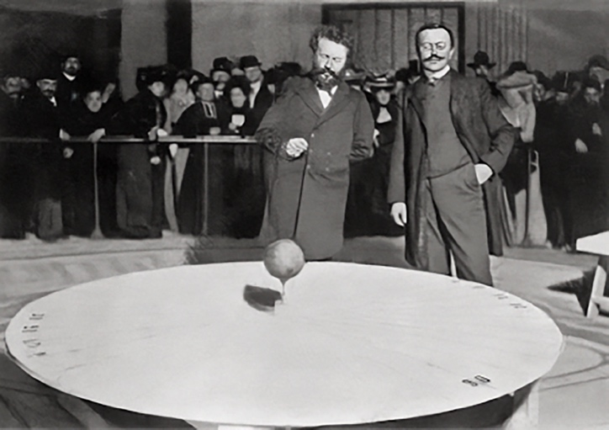

Fig. 1. L. Foucault and his pendulum.

The pendulum presented in this paper is highly reduced version of the original free pendulum that is forced version one. The movement is sustained by an induction concentric coil.

Results and discussion

The earth that is not a Galilean frame of reference. A mass m moving at velocity v on the surface of the earth undergoes an acceleration that is described in equation (1):

$\vec{a_{c}}=2m\vec{Ω}∧\vec{v}$ (1)

where $ω$ is the angular rotation speed of the earth. This produces a virtual force in the non-Galilean reference that is called Coriolis force and that deviates to the west a mass heading north to south and to the east a mass heading south to north [1]. As the pendulum swings, the Coriolis force makes is rotate clockwise (in the northern hemisphere) at angular rotation speed $Ω$ given by the equation (2):

$ω=Ω∙sin(λ)$ (2)

where $λ$ is the latitude [2].

Being able to highlight the phenomenon on a pendulum of a small size (1.8m) needs a number of technical ansatzes. A particular care was taken in the general design (mechanical precision, choice of components and optimization of settings and degrees of freedom). In particular, the pendulum must be forced to keep the same amplitude to overcome damping. An optical sensor detects each passage of the steel ball and informs a programmable controller, which will power, in an optimized manner, a coil to sustain the oscillations of the pendulum and ensure a constant amplitude. A 'Charron' ring is placed 20cm below the pendulum's attachment point. This device, which the wire hits with each oscillation, is obligatory for a sustained pendulum. It eliminates the natural elliptical movement of the oscillations. The only possible oscillation is that of the plane. The Coriolis acceleration modifies this plane with a rotation speed of 11.9°/hour at the latitude of Lausanne. We have measured a rotation speed of 12.1±0.1 deg/hour.

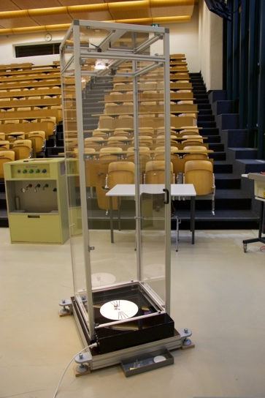

Fig. 2. Image showing the sustained Foucault’s pendulum.

Conclusions

We have realized a compact forced Foucault’s pendulum of good precision that is extremely helpful for demonstrations to a large public.

References

*Reference to a book:*

[1] V.I Arnold, *Capital: Mathematical methods of classical mechanics*, Springer-Verlag, New York, 1989

*Reference to a journal publication:*

[2] J.B. Hard, R.M. Miller, R.L. Mills, "A simple geometric model for visualizing the motion of a Foucault pendulum". *Am. J. Phys*. 55, 1 (1987) 67–70

**Max 2 pages for oral and poster communications**